**TestCases :**

Min support = 90%

Min confidence = = 90%

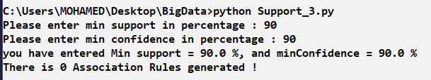

Min support = 50%

Min confidence = 50%

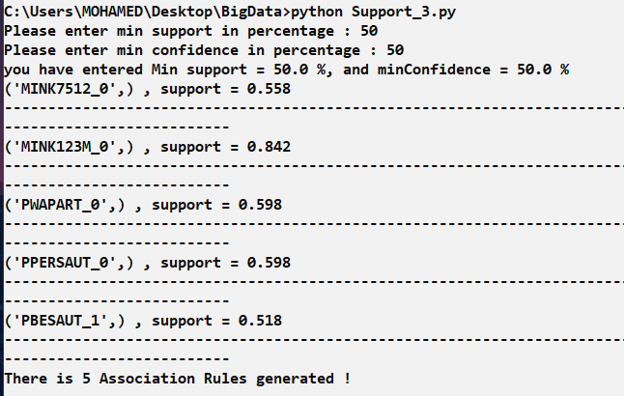

Min support = 30%

Min confidence =30%

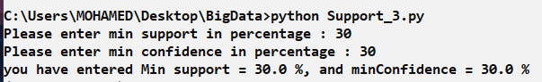

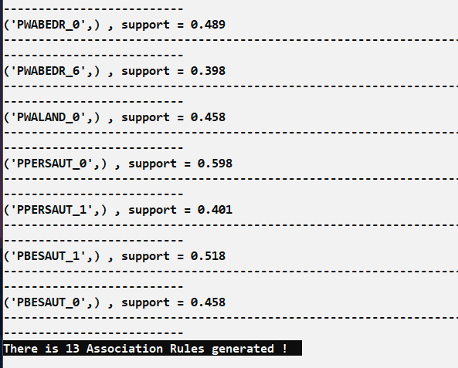

Min support = 10%

Min confidence = 10%

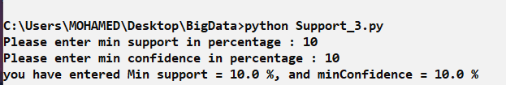

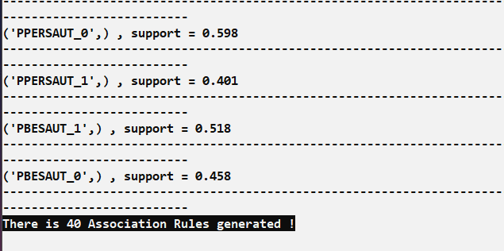

Min support = 1%

Min confidence = 1%

